Project proposal for the development and validation of a DIY profiling float for salinity estimation – draft 1

Caleb Flaim1

[cflaim@uw.edu](mailto:cflaim@uw.edu)

1University of Washington, School of Oceanography

30 October 2023

**Key words:** AUV, low-cost, open-source, halocline, mixing

**Running header:** openFloat proposal

**Project summary**

This project aims to quantify haloclines in Colvos Passage Puget Sound, WA, by building a DIY profiling float that costs ~500 USD to manufacture. Traditional autonomous underwater vehicles (AUVs) cost ~$100,000 or more. We hope to obtain high-quality data using traditional AUV deployment and propulsion methods with a DIY AUV. This reduces the financial barrier required to use AUV data collection methods for scientific research and also enables researchers to deploy more AUVs to obtain higher-resolution data.

The openFloat will collect 12-bit analog pressure and temperature, GPS location, lux, temperature, internal humidity, internal temperature, and internal pressure data. All data will be written to an onboard SD card and transmitted to an onshore base station via 915 mHz LoRa (long-range) radio. These data combined with the floats known mass and volume change should allow for an estimate of salinity to be back-calculated and used to observe how salinity gradients change in Colvos Passage during a December 12-hour tidal cycle.

**Introduction**

Autonomous underwater vehicle (AUV) oceanographic data collection methods that are standard today have revolutionized the way oceanographic data is collected since their conception in the mid 1950’s and development in the 1990’s (Eriksen et al., 2001; Gould et al., 2004). The development of such robots came to play since ship time at sea for scientific sampling can be prohibitively expensive and relatively course in resolution. While a ship may be able to perform conductivity, temperature, and depth (CTD) casts every few fractions of a degree, it is not able to do this for the entirety of the ocean, or even a smaller body of water such as Puget Sound.

Global-class research vessels, such as the RV Thomas G. Thompson, cost ~100,000 USD day-1 in 2023 (NEED REFERENCE, HAVE HEARD THIS NUMBER SAID A LOT) and cost 100,000,000 + USD to obtain and maintain (NEED REF). Costal ocean research ships, such as the RV Rachel Carson, cost ~30,000 USD day-1 (NEED REF) to operate in 2023 and cost 10,000,000 + USD (NEED REF) to obtain and maintain. Ocean-going research vessels of these types also require extend periods in dry dock for annual and unexpected maintenance. A typical seaglider or Argo float costs between 100,000 USD and 250,000 USD. This is greater or equivalent in price to a day of ship time at sea, but the instrument is operable for six to nine months in the case of the seaglider (Eriksen et al., 2001) or three to four years in the case of an Argo float (Gould et al., 2004). Deploying, using, and maintaining an AUV of this caliper is significantly cheaper than a month at sea performing CTD casts.

The AUV data collection methods discussed above are optimized for extended deployments in the open ocean where the average depth is 4,000 m and current speeds are typically less than 0.5 m s-1 (Eriksen et al., 2001; Gould et al., 2004), but are challenging to utilize in smaller bodies of water such as Puget Sound since the AUVs expend most of their energy avoiding the sea floor. Expensive iridium forms of telemetry are additionally unnecessary in urban oceans due to the prevalence of high-speed cellular networks in such locations. Cheaply buildable, rechargeable, and easily manufacturable AUVs such as Dr. Trevor Harrison’s swarm of microfloats (i.e., *µ*floats) (Harrison, 2021) pose an opportunity for the cheap collection of vast quantities of high-resolution data. We live during a time where low-cost, high-performance, low-power, and high-precision electronics are available in excess and promote DIYers (do it yourselfers) to develop new and innovative methods of sensing the world (see Yang et al., 2014; Assendelft et al., 2019; Lymen et al., 2020; Lauer et al., 2023 as a few examples). This project will build on the work of previous AUVs to develop an autonomous profiling float built from low-cost and easily-obtained electronics modules, such as those common for Arduino or RasberryPi internet-of-things or robotics projects.

**Proposed research**

This project proposes the design and build of an open-source autonomous profiling float – dubbed openFloat – for the collection of foundational oceanographic data variables such as temperature, pressure, and salinity. OpenFloat will use readily available electronics modules to collect, store, and transmit data. Common 3D printer motor control circuitry (e.g., Nema17 stepper motors and TMC2209 stepper motor drivers) will also be used to control the buoyancy engine. The float will collect 12-bit analog pressure and temperature signals, GPS positioning, time, digital light intensity, acceleration and absolute positioning, internal pressure, internal humidity, and internal temperature. These data will be stored on an internal 4GB SD card and later transmitted by LoRa radio via the 915 MHz industrial, scientific, and medical (ISM) band to a remote storage device shoreside or onboard the research vessel.

We hypothesize that a DIY profiling float can be built and collect basic oceanographic data of similar quality, proportional to its cost, to standard AUV data collection methods and be used to estimate halocline strength and depth in Colvos Passage, WA, without employing traditional salinity measurement techniques. We further pose that halocline strength and depth in Colvos Passage, WA, will not vary significantly during a 12-hour December tidal cycle due to high levels of mixing in the channel.

The float will be controlled by an Adafruit ESP32 Feather Huzzah, a microcontroller board that can be purchased for 20 USD or less. This board has processor speeds of up to 240 MHz (Adafruit Industries, 2023), a speed roughly 10 times as fast as the TT8 processor on the original seagliders (Freescale Semiconductor, 1995; Eriksen et al., 2001), and runs on 3.3 V logic. The ESP32 v2 that is used in the development of openFloat has 8 MB Flash memory, 2 MB PSRAM, built-in Bluetooth and Wi-Fi capabilities, and 21 available pins for signal input/output (see <https://learn.adafruit.com/adafruit-esp32-feather-v2/overview> for further detail). Furthermore, the ESP32 is capable of sub-milliamp deep sleep a with nominal current draw of 70 *µ*A. The fast processor speeds, large quantity of input-output pins, 12-bit analog pins, and low current draw of the ESP32 yields an opportunity for high precision and low-power data collection. The ESP32 will be used to read values from the modules described above and later transmit the data to shore (see Figure 1 for a preliminary wiring diagram and find more detailed information at <https://github.com/cflaim1123/openFloat>).

Once assembled, openFloat will be twice deployed alongside a seaglider – seaglider 175 for the first deployment and seaglider 195 for the second deployment – in Puget Sound. During the first deployment, the float will be tethered to a line and manually cast at ~0.1 m s-1 in Shilshole Bay (Figure 1a); during the second deployment, openFloatwill collect profile data in Colvos Passage (Figure 2b). Using the float pressure, temperature, and density data from the float’s rate of decent and known volume, we hope to back calculate salinity as an estimate. In both cases, the data collected by openFloat will be directly compared to that collected by the seaglider. We hope to produce transect plots similar to those in Bretschneideret al, 1985, who did a subtidal current study in East Passage Puget Sound – the channel on the opposite side of Vashon Island from our study site.

**Proposed timeline and budget**

**Timeline**

This project will occur in three main stages: the float development, data analysis, and manuscript writing stages (see <https://github.com/cflaim1123/openFloat/blob/main/proposal/timelines/flaimThesisTimelineFull.pdf> for the full Gannt chart project timeline). The float development stage is to occur from 27 September 2023 to 13 December 2023, the duration of the autumn offering of Ocean 443 (Table 1). This stage begins with the building and programming of the float’s electrical systems that do not pertain to the buoyancy engine. After the float’s data collection electronics are operable, the float will be deployed in the main basin of Puget Sound, WA, near Shilshole Bay Marina (Figure 2a) alongside a seaglider for an initial validation of the system’s data collection and pressure casing. During this deployment, the float will be tethered to a line and lowered to ~75 m to simulate a dive/surface sequence; we aim for the float to sink and rise at ~0.1m s-1 to match the average speed of a seaglider flying through water (Eriksen et al., 2001; Frajka-Williams et al., 2011). A manual cast of the float to this depth will take ~25 minutes in total and be performed every time the seaglider surfaces near the boat. This deployment will take six to eight hours. Once the initial test deployment is finished, the design and build of the buoyancy engine will take place.

The buoyancy engine will then be integrated with the float’s existing electrical systems and programmed to change volume given certain pressure, humidity, or acceleration signals. Finally, the float will be deployed in Colvos Passage, WA (Figure 2b) alongside a seaglider for data collection and comparison. This deployment will last approximately 12-hours – the length of half a tidal cycle. The proceeding two stages will occur during the winter 2024 academic quarter and largely follow the timeline of the Ocean 444 course.

**Budget**

This project aims to build a DIY profiling float in under 500 USD (see <https://github.com/cflaim1123/openFloat/blob/main/proposal/budget/openFloatBudget.pdf> for the full budget). Funding for this project will come from the University of Washington Ocean Technology Center’s project budget. Table 2 details the overall expenditure for the project to build to float from scratch – no parts were previously possessed. The electrical-sensing category is the largest expense for the openFloat project, followed by the Mechanical, Electrical-control, and Electrical-general categories. The total cost of building this float is ~530 USD, however, half of the price of materials are already possessed by the Ocean Technology Center. Approximately 260 USD of materials remain to be purchased. These cost estimates do not include compensation for the labor of designing, assembling, or testing the float.

**References**

Adafruit Industries. (2023, 10, 26). Adafruit ESP32 Feather V2. <https://cdn-learn.adafruit.com/downloads/pdf/adafruit-esp32-feather-v2.pdf>.

Bretschneider, D. E., Cannon, G. A., Holbrook, J. R., & Pashinski, D. J. (1985). Variability of subtidal current structure in a fjord estuary: Puget Sound, Washington. Journal of Geophysical Research: Oceans, 90(C6), 11949–11958. <https://doi.org/10.1029/JC090iC06p11949>.

Assendelft, R. S., & van Meerveld, H. J. I. (2019). A Low-Cost, Multi-Sensor System to Monitor Temporary Stream Dynamics in Mountainous Headwater Catchments. Sensors (Basel, Switzerland), 19(21), 4645–. https://doi.org/10.3390/s19214645

Eriksen, C. C., Osse, T. J., Light, R. D., Wen, T., Lehman, T. W., Sabin, P. L., Ballard, J. W., & Chiodi, A. M. (2001). Seaglider: a long-range autonomous underwater vehicle for oceanographic research. IEEE Journal of Oceanic Engineering, 26(4), 424–436. <https://doi.org/10.1109/48.972073>.

Frajka-Williams, E., Eriksen, C. C., Rhines, P. B., & Harcourt, R. R. (2011). Determining Vertical Water Velocities from Seaglider. Journal of Atmospheric and Oceanic Technology, 28(12), 1641–1656. <https://doi.org/10.1175/2011JTECHO830.1>.

Gould, J., Roemmich, D., Wijffels, S., Freeland, H., Ignaszewsky, M., Jianping, X., Pouliquen, S., Desaubies, Y., Send, U., Radhakrishnan, K., Takeuchi, K., Kim, K., Danchenkov, M., Sutton, P., King, B., Owens, B., & Riser, S. (2004). Argo profiling floats bring new era of in situ ocean observations. In Eos (Washington, D.C.) (Gould, J., et al. (2004), Argo profiling floats bring new era of in situ ocean observations, Eos Trans. AGU, 85(19), 185-191, doi:10.1029/2004EO190002., Vol. 85, Issue 19, pp. 185–191). Blackwell Publishing Ltd. <https://doi.org/10.1029/2004EO190002>.

Harrison, T. (2021). Buoyancy Controlled Float Swarms for Distributed Sensing in Coastal Waterways. ProQuest Dissertations Publishing.

Lauer, J. W., Klinger, P., O’Shea, S., & Lee, S.-Y. (2023). Development and validation of an open-source four-pole electrical conductivity, temperature, depth sensor for in situ water quality monitoring in an estuary. Environmental Monitoring and Assessment, 195(1), 221–221. <https://doi.org/10.1007/s10661-022-10493-y>.

Lyman, T. P., Elsmore, K., Gaylord, B., Byrnes, J. E. K., & Miller, L. P. (2020). Open Wave Height Logger: An open source pressure sensor data logger for wave measurement. Limnology and Oceanography, Methods, 18(7), 335–345. <https://doi.org/10.1002/lom3.10370>.

Freescale Semiconductor, Inc. (1995). M68300 Family MC68332 User’s Manual. <https://docs.rs-online.com/b7af/0900766b806a28f4.pdf>.

Yang, B., Patsavas, M. C., Byrne, R. H., & Ma, J. (2014). Seawater pH measurements in the field: A DIY photometer with 0.01 unit pH accuracy. Marine Chemistry, 160, 75–81. <https://doi.org/10.1016/j.marchem.2014.01.005>.

**Figure captions**

**Figure 1:**

Preliminary wiring diagram for the data collection and environmental sensing electronics of openFloat. The top of the board, from left to right, shows the GPS antenna, LoRa antenna, analog temperature sensor, digital temperature sensor, and lux sensor. The bottom of the board show the analog pressure sensor. Generally, green and white wires are I2C communication protocol; red and black wires are positive and negative power, respectively; goldenrod yellow wires are one-wire signal protocol; dark orange wires are enable pins; grey and maroon are RX and TX serial communication protocol.

**Figure 2:**

Panel a) shows the deployment location and likely track of seaglider 175 near Shilshole Bay, WA. Manual casts of the DIY float tethered to a line will be done at every seaglider dive sight to collect profile data. Panel b) shows the deployment location and likely track of seaglider 195 in Colvos Passage on the West side of Vashon Island. The DIY float will be deployed alongside the seaglider and allowed to drift down the passage while making continuous profiles. Red stars indicate possible seaglider and float dive sights or pickup locations. White lines represent the likely path of the seaglider or float once deployed. The red star circumscribed by a black circle indicates likely deployment locations. Actual deployment locations will vary depending on local boat traffic and tidal patterns.

**Tables**

**Table 1: Project timeline**

|  |  |  |  |
| --- | --- | --- | --- |
| **Project stage** | **Subsection** | **Start date** | **End date** |
| Float development | Concept development | 9/25/2023 | 10/04/2024 |
| Find and order parts | 9/25/2023 | 10/10/2023 |
| Background research | 10/02/2023 | 10/29/2023 |
| Electronics design | 10/09/2023 | 10/21/2023 |
| Electronics build | 10/20/2023 | 11/01/2023 |
| General programming | 10/30/2023 | 11/08/2023 |
| Float testing and deployment without profiling capability near Shilshole | 11/06/2023 | 11/10/2023 |
| Buoyancy engine build | 10/23/2023 | 11/03/2023 |
| Buoyancy engine build | 11/04/2023 | 11/20/2023 |
| Float assembly | 11/20/2023 | 11/26/2023 |
| Final float testing and deployment in Colvos Passage. | 11/27/2023 | 12/05/2023 |
| Data analysis | Produce desired plots to compare float data to seaglider data | 1/03/2024 | 1/11/2024 |
| Produce salinity transects of Colvos Passage | 1/11/2024 | 1/15/2024 |
| Produce engineering plots to asses float’s performance | 1/12/2024 | 1/16/2024 |
| Paper writing | Follow Ocean 444 assignment deadlines | 1/03/2024 | 3/12/2024 |

**Table 2: Project budget**

|  |  |  |  |  |
| --- | --- | --- | --- | --- |
| **Category** | **Item** | **#** | **Price per** | **Total price** |
| Electrical - general | perfboard (pack of 50) | 7 | $0.50 | $3.50 |
| Misc wires | NA | NA | $15.00 |
| Male header pins | NA | NA | $5.00 |
| Female header pins | NA | NA | $5.00 |
| Solder | NA | NA | $10.00 |
| Resistors | NA | NA | $0.10 |
| Misc GPS radio wires | NA | NA | $15.00 |
| Electrical - control | ESP32 feather huzzah v2 | 2 | $19.95 | $39.90 |
| BLDC motor | 1 | $30.00 | $30.00 |
| 5V, 5A voltage step-down regulator | 1 | $32.95 | $32.95 |
| custom battery pack | 1 | $15.00 | $15.00 |
| |  | | --- | | Electrical - sensing | |  | |  | |  | |  | |  | |  | |  | |  | |  | |  | | analog pressure sensor | 1 | $20.00 | $20.00 |
| Thermistor | 1 | $2.00 | $2.00 |
| adafruit data logger feather wing | 1 | $8.95 | $8.95 |
| digital temperature sensor (pack of 5) | 1 | $10.00 | $10.00 |
| BMP180 pressure sensor | 1 | $9.95 | $9.95 |
| DHT22 humidity sensor | 1 | $9.95 | $9.95 |
| TSL2591 lux sensor | 1 | $6.95 | $6.95 |
| Adafruit 9-DOF absolute orientation IMU - BN055 | 1 | $35.00 | $35.00 |
| Adafruit ultiamte GPS | 2 | $30.00 | $60.00 |
| 915 mHz LoRa radio module | 2 | $20.00 | $40.00 |
| Precision current meter | 1 | $10.00 | $10.00 |
| GPS antenna | 1 | $20.00 | $20.00 |
| Radio antenna | 2 | $10.00 | $20.00 |
| |  | | --- | | Mechanical | |  | |  | | Low-pitch, high-precision ACME lead screw | 1 | $15.00 | $15.00 |
| Misc O-ring | NA | NA | $10.00 |
| Misc PVC pipe for piston | 1 | $10.00 | $10.00 |
| 4" PVC pipe | 1 | $20.00 | $20.00 |
| 4" PVC endcaps | 2 | $10.00 | $20.00 |
| metal cable glands | 5 | $10.00 | $50.00 |
| Epoxy | 2 | $10.00 | $20.00 |
|  | | | Total: | $529.25 |

**Figures**

**Figure 1**

**Figure 2**

a)

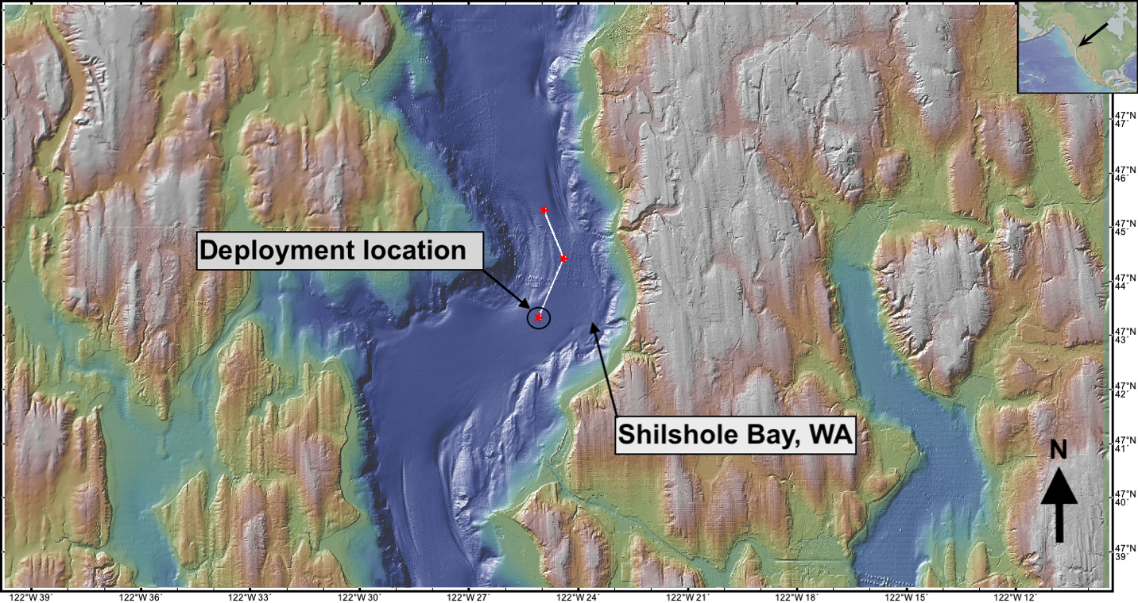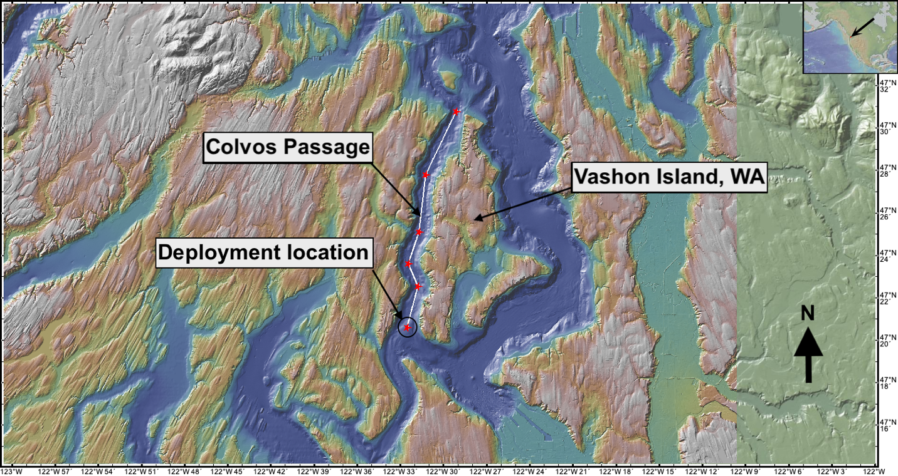

b)